**IDE2E Test**

**Part 1:**

Write a Service layer bean to do the following:

The Service layer project is created using Java Maven. The library used for the service layer is “**org.springframework.boot**”.

The framework consists of the below modules:

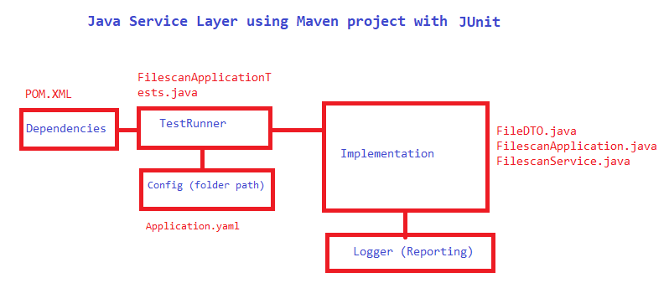

1. Scan configured directory in file system which will return this information > filename, file mime type, file size, file extension.

Package**: com.exercise.filescan** inside folder **src/test/java**

Class: **FilescanApplicationTests.java**

Method: **testConfigScan**

2. Use a directory containing a reasonably large number of files, minimum 10.

For testing I have created a directory tmp/exercise inside your project where I have saved 10 files of different mime types and extension. The folder path is saved in **src/main/resources/application.yaml**

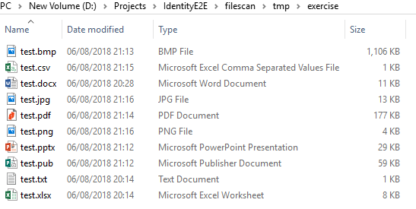

3. Provide a way to retrieve certain supported mime type files: configure excel and csv are supported currently

Package**: com.exercise.filescan** inside folder **src/test/java**

Class: **FilescanApplicationTests.java**

Method: **testConfigScanWithMime**

Run **FilescanApplicationTests** class as Junit test and the output will be display as below

**Output in Console window:**

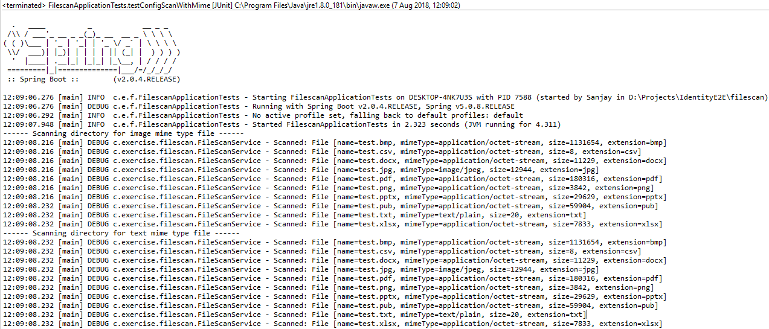

**Output in Junit window as the framework used Junit as test runner:**

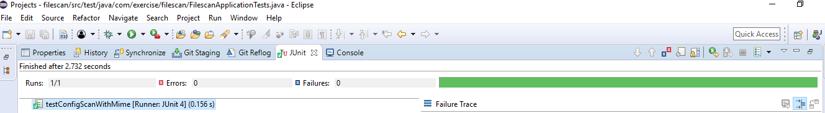

**Part 2:**

Write a selenium/cucumber framework to do the following:

1. Use the above service layer bean to get supported files (excel or csv are supported, from input directory)

2. Go through the file and read vehicle registration details in the file.

3. Open web page : https://www.gov.uk/get-vehicle-information-from-dvla and go through all vehicles from excel/csv file.

4. On the Vehicle details page assert the details (Make/Color) match with expected output in excel/csv file.

The Selenium Junit automation framework using POM Design patter implemented by PageFactory has the below modules:

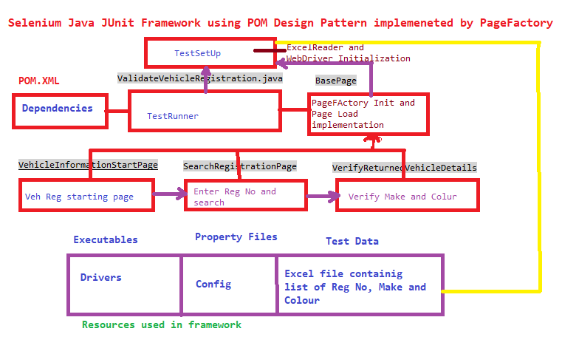

* The TestRunner starts with validateVehicleRegistration method inside ValidateVehicleRegistration class.
* VehicleInformationStartPage open the DVLA start page where the user click continue to start Vehicle registration search.
* In SearchRegistrationPage the user will enter the Vehicle Registration number retrieved from Excel sheet using ExcelReader class.
* The valid registration number take the user to VerifyReturnedVehicleDetails page where the Colour and Make of the entered Vehicle Registration will display. In this page we are verifying these details matched with the details in excel sheet

**The test run output will be as below:**

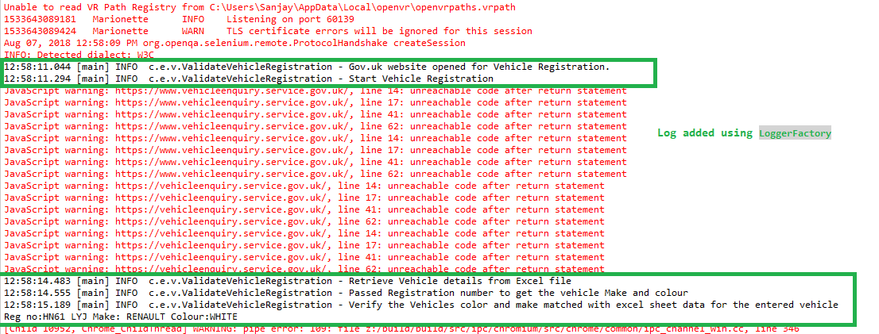



The complete Automation Test Framework code is uploaded in GitHub

<https://github.com/SanjayAdav1972/IdentityE2E>